Original tutorial link:

<https://www.youtube.com/watch?v=nKQljsGmFI0>

[The excellent Polygon Runway]

1] Select everything in the default blender file and delete it (shortcut key = x): -

Let’s begin by placing a flat circle on the ground,

From the menu select: - ADD > MESH > CIRCLE

The parameter box in the bottom left always you to change various properties of objects as you add them to your scene. Here we have “Add Circle” – open the box up and reduce the Vertices parameter from 32 to 16, you can then click anywhere outside the box to finalise the add and dismiss the box.

Make sure the circle is selected (it will be highlighted in orange if it is). If not selected you can click anywhere on it to select it, or select it in the object navigator in the top right.

Press “7” on the **number pad** on your keyboard (hopefully you have one as blender uses it for a lot of view changing shortcuts) and the view should change in to “top” mode where you view the circle directly from above, use the mouse wheel to zoom in until the circle fills most of the screen: -

Each large square you see on this grid is 1 meter on each side. And so each small square is 10cm on each side. This current circle is far to big for a chair at about 2 meters in diameter -!

We need to scale it down – press the “Tab” key or change mode from the drop down to enter Edit Mode – edit mode is for making direct edits to an object after it has been placed in the scene.

Press “S” and use the mouse to scale the circle down until the diameter is roughly 5 small boxes long – that is about 50 cm: -

Now press “CTRL + F” (hold down CTRL key, bottom left or bottom right then with it held also press “F”) – this will bring up a “Face” menu – and from it select the “Grid Fill” option,

This will fill our shape with a pattern of individual faces.

You may have to adjust the offset setting in the parameter box until you have a fill that looks like this:

Now press “G” (the shortcut for “Grab”, to move selected objects about in 3d space),

And then press “Z” (to lock the movement to the Z axis only which is up/down in Blender).

And use the mouse to move the object up about 45 cm or so off the ground, that is about 4.5 small squares.

Go back to Top View by Pressing “7” on numpad.

And click the icon shown in blue at the top to turn on “Proportional Editing”.

Select the two vertex points highlighted here – to select two first select one by clicking on it then hold shift whilst clicking the second one.

Now press “S” and then “X” (to lock scaling on just the x-axis) and adjust the shape until you have something that looks somewhat like this, note you also use the scrollwheel on your mouse to lessen the effect: -

This is the seat of our chair basically.

Now as also shown above select the vertex at the very bottom, and press “G” then “Y” and flatten the front edge a little to something like the above, and same at the top: -

Select the whole object again, by drawing a selection box around it all, or by pressing “A”, and scale the seat back up a little with “S”: -

The next task is to select just all the edges around the outside of the seat –

Press “ALT+A” to unselect everything, then use the mouse middlebutton to rotate the view to something like this and click the “edge” selection option in the top left :-

We need to select all the edges on the outside of the shape, you can do this the slow way by selecting one, then shift selecting the rest but a slightly faster way is: -

Hold ALT, then select one edge on one side – this will automatically select all the edges on that side, then move to the next side, again press ALT but now also SHIFT and do similar as well, and do this for all 4 sides.

Either way, you should end up with all the edges around the outside of your shape now selected at once: -

Next, we want to “Duplicate” this edge ring. Pressing “Shift + D” is the shortcut to make a quick duplicate of whatever is selected – move the mouse just to confirm it is made, but then right click the mouse and this will drop it back exactly on top of the original edge ring (which is what we want):

Now press “P” and choose “Selection” from the separation menu that pops up – this will separate the selected edge ring into a new object of its own – you can see that in the object navigator top right: -

Press the Tab key on your keyboard to return to “Object Mode”, and now select this new object instead (you can click on it on the object navigator).

Tab back into Edit Mode – press “A” to select the whole edge ring again then: -

Press “E” (for Extrude – this is used to “grow” selected objects through 3d space) and then press “Z” to lock the extrude to just the up-down Z axis and extrude the edge ring downwards as below: -

Press “Tab” and return to object mode – and we will begin adding some “Modifiers” which are special and very powerful Blender tools that can help you edit some parts of your object models automatically:

1st one – Solidify : -

Open the modifiers panel, open the dropmenu and select the “solidify” modifier: -

And increase the “Thickness” setting to: 0.025m, as you do so you will see the extruded edge ring object now thicken into a 3d shape: -

Collapse the Solidify box (click on the small arrow top left of box), and let’s now add a 2nd modifier – this time one called “Bevel” – this is for rounding curved surfaces: -

Set the amount field to 0.006 m and the number of Segments to 2: -

And now a 3rd modifier – this one “subdivision surface” – this subdivides surfaces into extra surfaces to produce smoothing effects: -

Increase the “Levels” setting to 2: -

That’s looking quite good, but if you orbit around your model, some of the angles especially at the back are still too sharp: -

We can improve this by reopening the “Bevel” modifier box and making some adjustments: -

Increase the Angle setting to something like about 60 degrees (you can experiment to your own liking) until you have a fully rounded corner that looks something like below: -

To finish this section, let’s make the original face surface roughly the same shape too, so select the original object and add just one modifier – the subdivision surface and turn levels up to 2 also,

You should now have something like below: -

Tab into edit mode, press “A” to select all, then use G then Z to move the seat of the chair down into the object to create a sort of cushion effect inside the frame of the chair: -

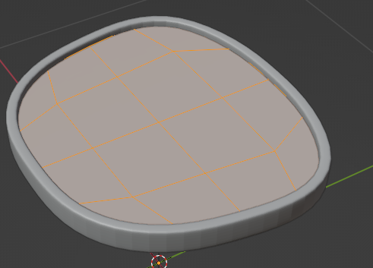

Turn off “Proportional Editing” by unselecting the icon highlighted in blue we turned on earlier.

Then press “ALT+A” to unselect everything.

Go back to Face Select – (the shortcut for this is the normal “3” key at top of your keyboard, 1 is for vertex selection, 2 for edge selection) :-

Then select the middle 4 faces and press G then Z and move them down a small bit, this will create a suggestion of curvature in the center of your chair seat:

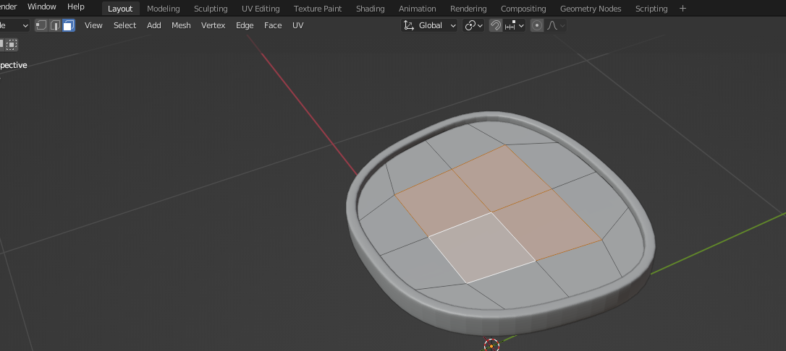

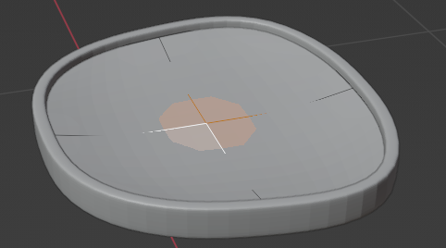

That’s the seat done, next stop – Chair Legs!

We are going to use an optional feature that isn’t turned on by default in initial Blender installations, if you don’t have it turned on, you can do so now as follows: -

EDIT > PREFERENCES

Select “Add-Ons” on the left then in the search bar enter the keyword “Extra” and search: -

For this next step, we need: “Add Mesh: Extra Objects” turned on – to do this simply put a tick in the white checkbox as shown, and close down preferences -easy as that!

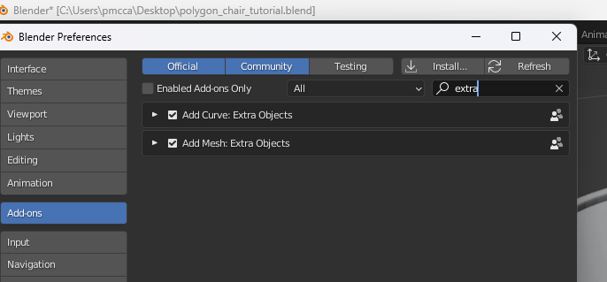

So now to grow the first chair leg, we are going to start from a single vertice point (!)

**Return to object mode –**

Then let’s go to Add menu (from menu at top, or shortcut is “SHIFT+A” and “mesh” submenu)–

then select the following option: -

This places one single vertex dot at the world origin (as this is where the 3d cursor is located currently). You will also see it appear as a new object in the object navigator

Switch back into Edit mode.

**Change the selection mode to vertex selection mode** (Press “1” at top of keyboard as a shortcut).

And select the vertex.

Press “3” on the numpad to change to side view.

Press “G” then “Y” and move the vertex towards the front of the chair: -

Now hold down CTRL and right click with the mouse to make a chair leg like curve something like below – note the last vertex click should be about halfway inside the chair cushion:-

Ok – next we need to position this new proto-leg: -

Press “A” to select the whole leg at once, then press Numpad 7 for top view, and toggle on x-ray mode – this will allows us to see and position the leg “through” the chair seat: -

Press “R” to enter rotate, and rotate to about a 45 degree angle.

Then use “G” to move it to the front left corner of the chair something like so: -

[Incidentally, we don’t need to lock the “G” move to an axis here, because blender is clever enough to know that as we are looking down from directly above, the object should only move on x and y axes when we move with the mouse].

Let’s duplicate this leg to make the second leg –

Press 3 on Numpad to switch to the side on view.

Press Shift+D followed by “Y” to make a duplicate and only move it on the y-axis – even though it points the wrong way for the moment, move it to roughly where the next leg should be like so: -

Press numpad 7 to go back to top view, press r to rotate the new leg and G to move it more towards the corner like so: -

Tab out back into Object Mode – select all and right click and select “convert to curve”.

We now have a curve settings tab – open “Geometry” and increase the **Bevel** depth to something like **0.03m** to thicken the legs: -

Tab back into Edit Mode

Turn back on “Proportional Editing”: -

Select only the bottom two vertices then use Alt + S to make the legs taper and end in small points: -

[you can also use the mouse wheel to increase the radius of the effect over the leg as a whole]

We can use a mirror modifier to automatically complete the other two legs as an identical copy – tab back to object mode and with the legs object selected – go to modifiers and add a mirror modifier

The default in X should do if you have aligned as above, but change mirror axis if needed.

Next let’s make the backrest.

Select the seat part again, tab into edit mode, select the vert at the front and press SHIFT+S and select cursor to selected: -

Return to Object mode, and press Shift+A and add another single vert at this position.

Press “1” for front view, then Press G and move the vert down into the seat to roughly this position : -

Turn OFF proportional editing before continuing..

Use CTRL + right click to grow the headrest but stop just short off the mid pt at the top

Add a mirror modifier – and in it tick clipping on

Then press G and the Z and you will find the object join exactly in the middle

You can select the vertices on at a time now, and use G moves to improve the shape somewhat by eye..

Press A to select all, then numpad 3 side view, then G plus Y and move it back a little from the seat to allow for thickness to follow: -

**Turn proportional editing back on** then

Still looking from the side, select only the top vertice of the back, then press G then Y and bend the back backwards as below: -

[You might also need to select some of the vertices lower down and move similar to get a nice smooth flowing shape]

Tab back out to object mode, right click on the backrest object and select **Convert To >> Curve**:

In the object data properties tab, increase the depth in the “Bevel” section to about 0.02m :-

And the curve should thicken as so: -

Tab back into edit mode, select the top vertice, and press Alt+S to thicken the top part of the loop somewhat: -

We want to make a smaller duplicate of this back loop to make the inside back of the chair, an easy way to do this quickly is the following steps: -

1] Select the bottom two vertices then press Shift+S and in the pop-up menu select “cursor to selected”. The 3D cursor moves between the two vertices.

2] Tab back to Object Mode, right click on the object and select “set origin >> to 3d cursor”. This means when we make a duplicate and scale in next step the origin of the scale is centered on this point, which is what we want.

3] Press Alt + D to duplicate the loop, then use S to scale it down, you can also use S+X to narrow it a bit – the end result should look something like this: -

If the back rest is “floating” a bit away from the seat, select both parts and use G+Y to move them into contact with the seat proper.

**Last part is to put connectors between the back and front legs to make our chair a bit sturdier.**

Press Numpad 3 to look from the side again, and Shift + S and select “cursor to world origin” to put the 3d cursor back in the intersection point of all the axes again: -

Add another “single vertex” using the Shift + A menu.

Then making sure you have the single vertex selection on, switch to object mode, press G and move it to the near back leg, turn off proportional editing , tab into edit mode and then use “E” extrude commands to built the underneath strut like below: -

Select it all, then switch to the top view and activate X-ray mode: -

And move it over to between the top two legs, including a rotation so it runs from one to the other like so: -

Tab back into object mode, right click and once again select “convert to curve”.

Again increase the bevel depth in object data properties, here to about 0.015m.

Tab back into edit mode and move the end vertices to join the strut into the chair: -

Like for the other parts, add a mirror modifier to automatically get one on the other side too: -

To finish in object mode select each part in turn and press Ctrl + 2 to add 2 level subdivisions: -

And finally select all objects, right click and select “shade smooth”.

And that’s it!